Report format for Project

1. Introduction

we will discuss how to retrieve username and password from an HTTP website. HTTP is a protocol that allows web browsers and servers to communicate and exchange data. However, HTTP is not secure and does not encrypt the data that is sent or received. This means that anyone who intercepts the network traffic can see the information that is transmitted, including the username and password of a user who logs in to a website. This poses a serious risk to the user's privacy and security.

To retrieve username and password from an HTTP website, we need to use a tool that can capture and analyse the network traffic. One such tool is Wireshark, which is a free and open-source software that can monitor and inspect network packets. Wireshark can filter and display the data that is relevant to our purpose, such as the HTTP requests and responses that contain the login credentials.

* 1. Objective of the project

The objective of this task is to retrieve the username and password of a user who logs in to a website that uses the HTTP protocol. This can be done by intercepting and analysing the network traffic between the user's browser and the website's server, as HTTP does not encrypt the data sent or received.

* 1. Description of the project

To retrieve username and password from an HTTP website, we need to inspect the network traffic between your browser and the server. You can use a tool like Wireshark to capture and analyse the packets that are sent and received when you log in to the website. If the website does not use encryption or HTTPS, you may be able to see the username and password in plain text.

* 1. Scope of the project

Scope of the project is to retrieve username and password from HTTP website using Wireshark open-source tool.

1. System Description
   1. Target system description

Windows 11 is the targeted system to retrieve username and password from HTTP website is testphp.vulnweb.com

1. Analysis Report
   1. System snapshots and full analysis report
2. Open wireshark
3. Login to testphp.vulnweb.com

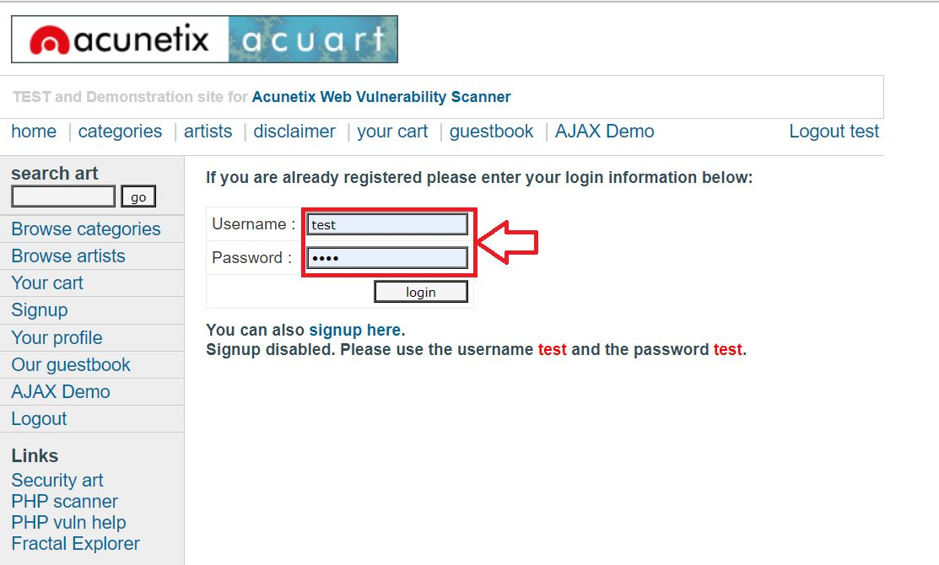

Fig.1: Logging to testphp.vulnweb.com

1. Double click on Wi-Fi area in Wireshark Home page

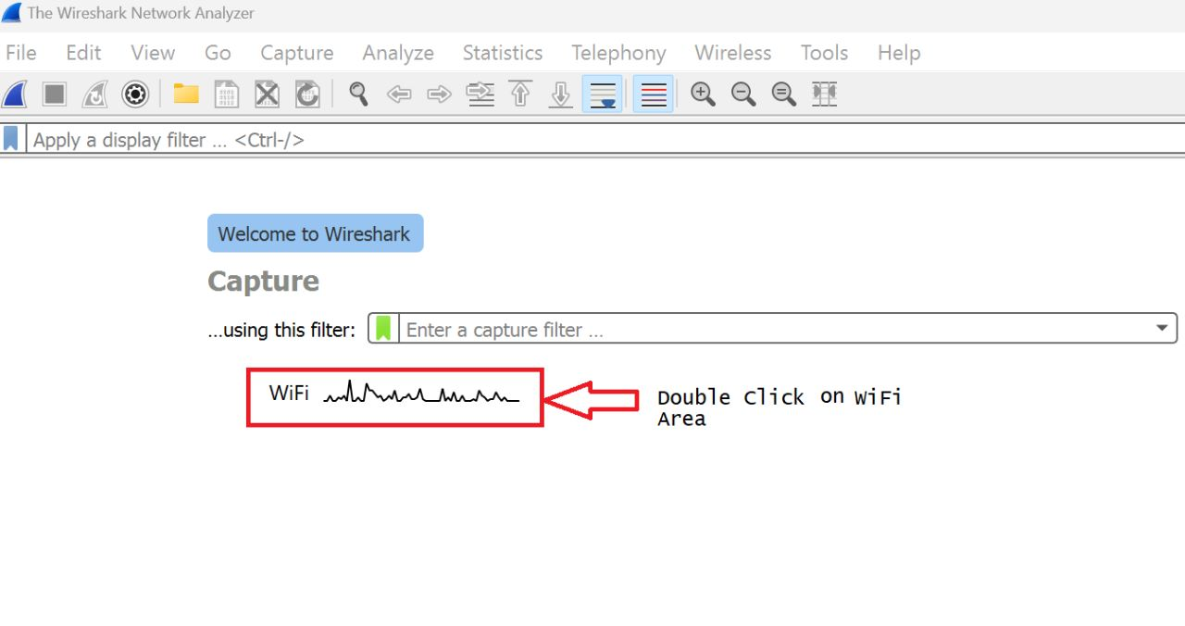

Fig.2: Wireshark Home Page

1. Right click in any one of them.

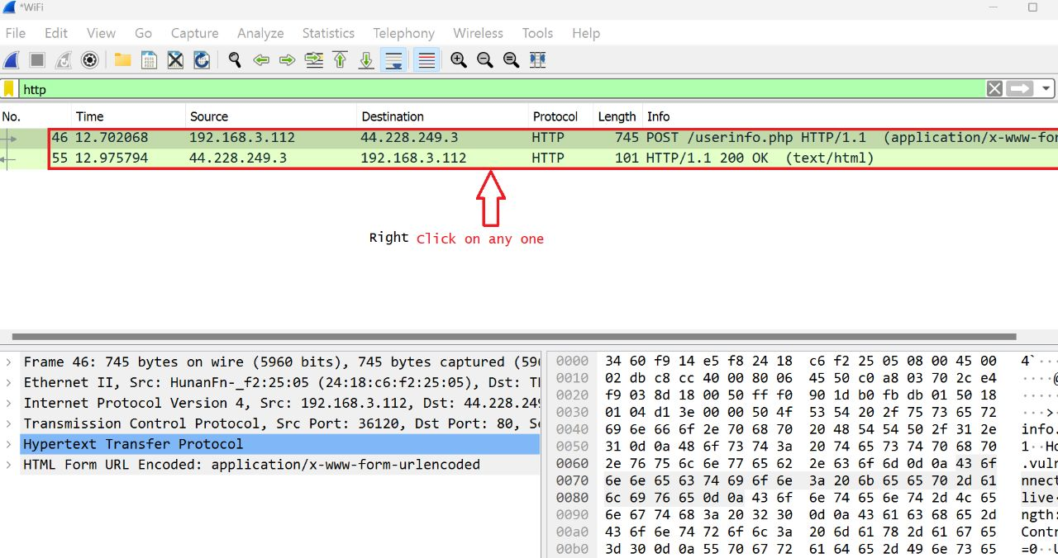

Fig.3: Right click on any one

1. Type HTTP in apply Filter Search Box.

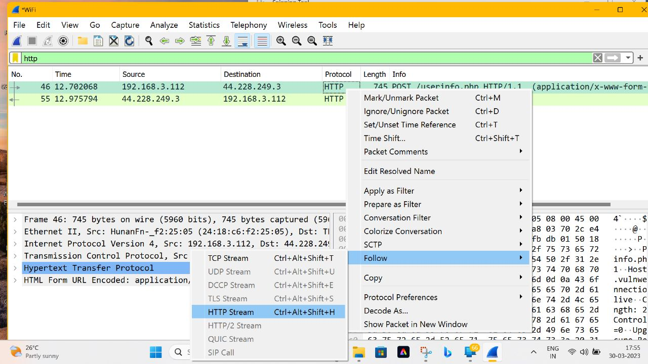

Fig.4: Search HTTP

1. Finally, Username and Password Found.

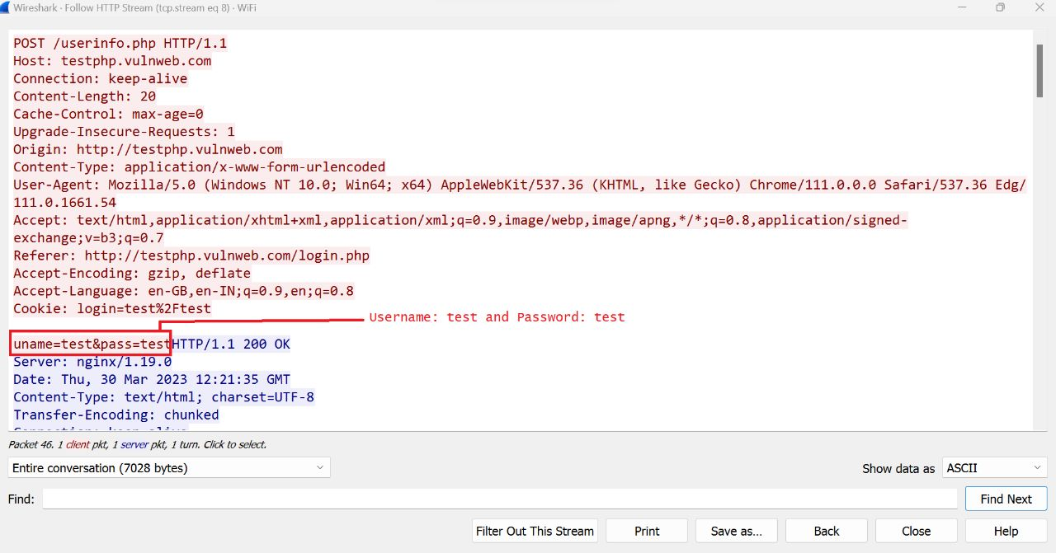

Fig.5: Username and Password retrieved from HTTP website

1. Reference/Bibliography

[Get username and password of any website using wireshark must watch. - YouTube](https://www.youtube.com/watch?v=GX3hSkcDpRo&ab_channel=SoumenKhara)

GitHub Link: https://github.com/Anilac547/CA3-Repo.git